##### Zomato App

###### Customer Onboarding Journey

Version Change Info: 14.2.3

Current Version: 15.9.5

English

Table of Contents

1 Zomato Overview 3

2 Key Attributes 3

3 User’s Onboarding Journey 4

4 Change Log 9

# Zomato Overview

Deepinder Goyal, Pankaj Chaddah, and Gunjan Patidar founded Zomato, an Indian multinational restaurant aggregator and food delivery company, in 2008. Zomato offers restaurant information, menus, and user reviews, as well as food delivery from partner restaurants in a few cities. Zomato was founded in 2008 as Foodiebay and renamed Zomato Media Pvt. Ltd. on January 18, 2010.

# Key Attributes

Every person who makes use of any product or service had to start somewhere. Even if they've used a similar product or service before, each one will present new challenges, styles, layouts, interaction methods, and things to learn. The overall experience will be used by that person i.e, a customer, or a user.

When a user first opens the Zomato App, they must understand what they can do and how they can do it. The procedure should also be quick and easy to complete with the least amount of effort. To improve engagement and encourage the user to investigate the available options and hopefully find things that are of interest to them personally, it is to make things clear, visible, and easy to learn from the start.

Some of the queries that pops up in a user’s mind:

**What am I doing here?** - Inform the user about the Zomato, which is the online food delivery service and leave no doubt that they are at the start of their explorations of the App.

**What can I do?** - Let the user know what they can do with the service.

**What options do I have?** - Once you've communicated the service that you are providing and some of the things they can do, you need to let them know where they can go next.

The UX Design is one of the most intimidating aspects of a user's experience. The customer is not sure if they have chosen the right service or if they are looking at the right thing, or if they have arrived at the right location. These are some of the key attributes to keep in mind while designing an App.

# User’s Onboarding Journey

The food technology industry is fiercely competitive, with steep discounts, rising operating costs, and erratic customers. To be successful, you need as many people as possible to fall in love with your app and continue to use it over time and time.

Instant gratification is the driving force behind the food tech industry. Hungry people don’t like to wait for their food! So, to create the ideal onboarding flow for the app, stick to the 3 Ss principle: Short, Simple, and Speedy.

1. Installation of Zomato App.

The Android or the iOS users can open their Google Play Store and App Store respectively. They can type Zomato in the search bar option. So, this Zomato App will appear on the screen as shown below.

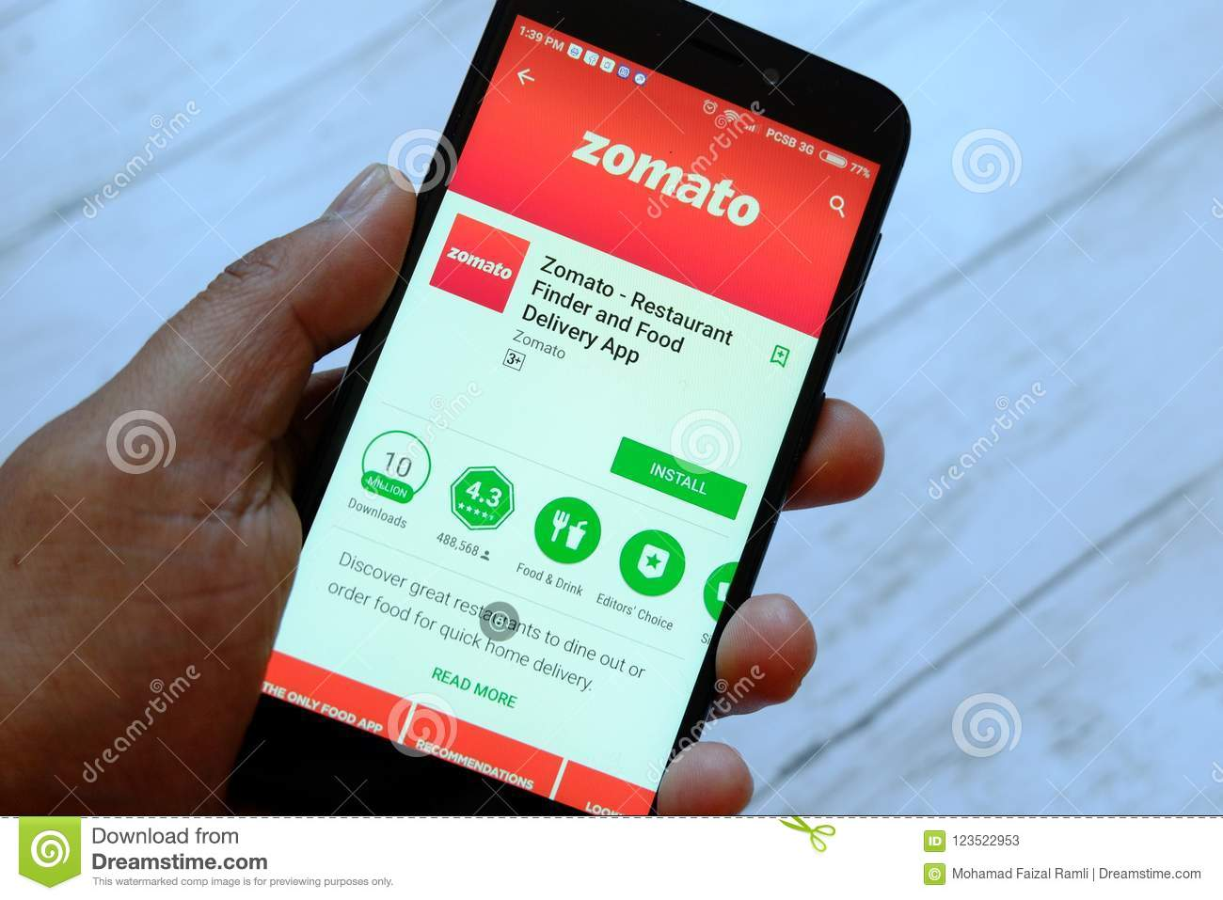

Click **Install** to download the App from the respective Stores. Once it is downloaded, they can open the App to experience the UI design.

1. An appealing Welcome Screen.

In as few words as possible, your value proposition should be communicated on your Welcome screen. Avoid stuffing your Welcome screen with too much text, even if your app is a little more complicated. Keep it simple. Strike a balance between communicating your USP and generating interest in your app so that users want to learn more about it.

1. Push Notification Options.

Zomato provides a great first-time user experience when users see the push notifications which is actually helpful; they are also setting the stage for better engagement and retention down the road.

1. It asks for the Location Access.

Zomato gently persuade first-time users to allow geolocation sharing by describing how they will benefit in the long run. It allows them to build trust among the users and for the satisfying user experience. This information which is being used to target users with highly personalized engagement strategies in real time. First-time users can share their location with Zomato using either GPS detection or manual entry. Users can choose the GPS detection or can manually edit the address.

1. Sign Up Process.

Zomato made the onboarding process quick and simple. It allows users to sign up for the app using the Gmail, Facebook, or any other account of their choice. It made easier for first-time users to log in, and on the other, Zomato is collecting the personal and social data from the users. So, users can sign up automatically using any account or can manually sign up for the app.

1. Asking users to complete their profiles.

It allows Zomato to collect information such as users' delivery addresses, which could be classified as "work," "home," or "favourite cuisines," among other things. This also lays the groundwork for attributing the creation and curation of user-generated content on the user’s platform. Users can fill all the details.

1. Features

The first-time users are guided to the app's actual interface, by making a brief mention of how they can use and/or benefit from the app's features and Zomato provides a Skip button to finish the tour.

1. Visually engaging experience.

Zomato indulges in providing images of burgers, pastas, biriyanis, pizzas, and noodles, etc., which will always make users hungry for more!

Zomato included a direct call-to-action at the conclusion of the onboarding process so that users know what to do next. Getting users to engage with your app right away helps them grow as engaged users and allows them to become excited about it.

# Change Log

Version Change Info: 14.2.3

Current Version: 15.9.5

Latest Update: -

1. Order food online
2. Track your order
3. Avail food offers and discounts
4. Contactless food delivery and dining
5. Become a Zomato Pro member
6. Pick up your order
7. Discover top restaurants, cuisines, and dishes
8. Access restaurant details
9. Book a table to avoid queues

